Assignment 3

Name : Nazibul Islam Nabil
NSU ID : 2222456642
Course : CSE331
Section : 11
Date : 23-08-2025

a
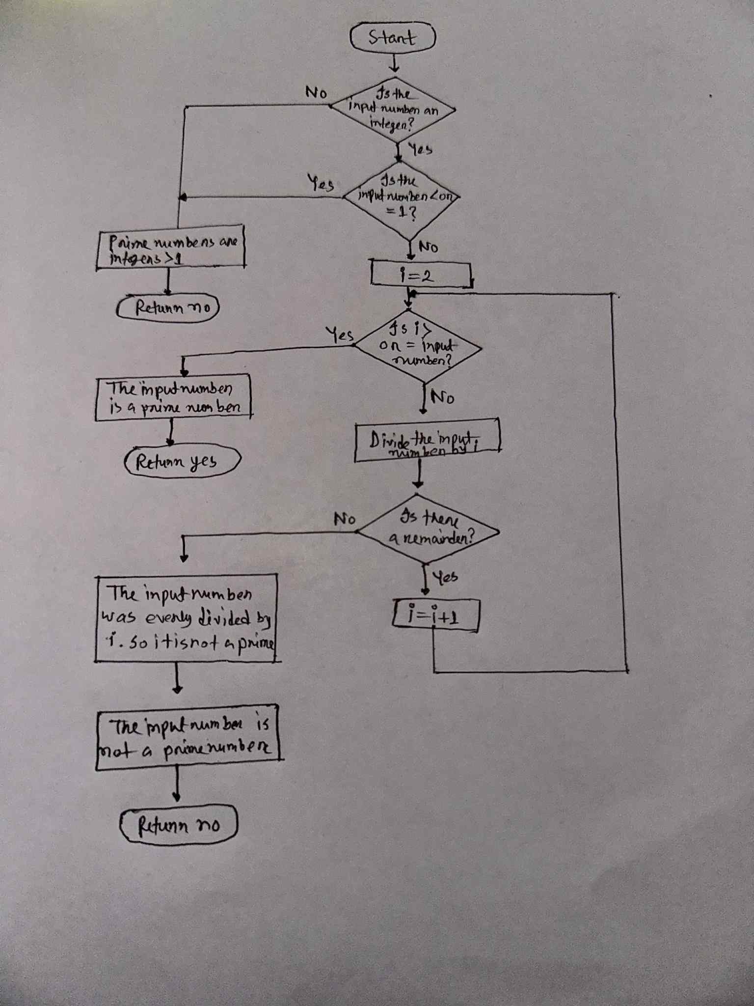

b
#include <stdio.h>
int is_prime(int n) {
if (n <= 1)
return 0;
for (int i = 2; i * i <= n; i++) {
if (n % i == 0)
return 0;
}
return 1;
}
int main() {
int integers[] = {4, 7, 11, 14, 16, 21, 23, 27, 29, 38, 39, 41, 47, 49, 53, 55, 69, 97, 99};
int n = sizeof(integers) / sizeof(integers[0]);
printf("Prime numbers:\n");
for (int i = 0; i < n; i++) {
if (is_prime(integers[i])) {
printf("%d ", integers[i]);
}
}
return 0;
}
c
.data
integers: .word 4, 7, 11, 14, 16, 21, 23, 27, 29, 38, 39, 41, 47, 49, 53, 55, 69, 97, 99
n: .word 19
prime_flag: .space 76
.text
.global _start
_start:
ldr r0, =integers
ldr r1, =n
ldr r1, [r1]
mov r2, #0
check_prime:
ldr r3, [r0, r2, LSL #2]
bl is_prime
cmp r0, #1
beq mark_prime
add r2, r2, #1
cmp r2, r1
blt check_prime
display_primes:
mov r0, #0
ldr r1, =msg
ldr r2, =msg_len
mov r7, #4
svc 0
_exit:
mov r7, #1
svc 0
is_prime:
mov r4, #2
cmp r0, #1
ble prime_exit
cmp r0, #2
beq prime_exit
check_divisor:
mov r5, r0
sdiv r5, r5, r4
mul r6, r5, r4
cmp r6, r0
beq prime_exit
add r4, r4, #1
mov r5, #0
cmp r4, r0
blt check_divisor
prime_exit:
moveq r0, #1
movne r0, #0
bx lr
mark_prime:
ldr r5, =prime_flag
ldr r6, =msg_len
ldr r7, [r5, r6]
add r7, r7, #1
str r7, [r5, r6]
ldr r7, =msg_len
ldr r8, [r5, r7]
cmp r8, r3
bge continue_check
str r3, [r5, r7]
continue_check:
add r6, r6, #4
mov r7, #0
str r7, [r5, r6]
b check_prime
.data
msg: .asciz "Prime numbers:\n"
msg_len: .word 25

d
.data
integers: .word 4, 7, 11, 14, 16, 21, 23, 27, 29, 38, 39, 41, 47, 49, 53, 55, 69, 97, 99
n: .word 19
prime_flag: .space 76
.text
.global _start
_start:
ldr r0, =integers
ldr r1, =n
ldr r1, [r1]
mov r2, #0
check_prime:
ldr r3, [r0, r2, LSL #2]
bl is_prime
cmp r0, #1
beq mark_prime
add r2, r2, #1
cmp r2, r1
blt check_prime
display_primes:
mov r0, #0

e
.data
integers: .word 4, 7, 11, 14, 16, 21, 23, 27, 29, 38, 39, 41, 47, 49, 53, 55, 69, 97, 99
n: .word 19
prime_flag: .space 76
.text
.global _start
_start:
ldr r0, =integers ; 0xE59F0000
ldr r1, =n ; 0xE59F1000
ldr r1, [r1] ; 0xE5911000
mov r2, #0 ; 0xE3A02000
check_prime:
ldr r3, [r0, r2, LSL #2] ; 0xE7903000
bl is_prime ; 0xE12FFF1E
cmp r0, #1 ; 0xE3500001
beq mark_prime ; 0x0A000001
add r2, r2, #1 ; 0xE0822001
cmp r2, r1 ; 0xE1520001
blt check_prime ; 0xBAFFFFF8
display_primes:
mov r0, #0 ; 0xE3A00000
ldr r1, =msg ; 0xE59F1010
ldr r2, =msg_len ; 0xE59F2014
mov r7, #4 0xE3A07004
svc 0 0xEF000000
_exit:
mov r7, #1 ; 0xE3A07001
svc 0 ; 0xEF000000
is_prime:
mov r4, #2 ; 0xE3A04002
cmp r0, #1 ; 0xE3500001
ble prime_exit ; 0x02FFFFFD
cmp r0, #2 ; 0xE3500002
beq prime_exit ; 0x01A0000A
check_divisor:
mov r5, r0 ; 0xE1A05000
mov r6, #0 ; 0xE3A06000
mov r7, #0 ; 0xE3A07000
divide_loop:
add r6, r6, #1 ; 0xE2866001
sub r5, r5, r4 ; 0xE2454004
cmp r5, #0 ; 0xE3500000
blt divide_exit ; 0x08FFFFF9
cmp r4, r5 ; 0xE1540005
bge divide_loop ; 0x1AFFFFF8
divide_exit:
sub r6, r6, #1 ; 0xE2466001
mov r0, r6 ; 0xE1A00006
bx lr ; 0xE12FFF1E
prime_exit:
moveq r0, #1 ; 0x03A00001
movne r0, #0 ; 0x01A00000
bx lr ; 0xE12FFF1E
mark_prime:
ldr r5, =prime_flag ; 0xE59F501C
ldr r6, =msg_len ; 0xE59F6020
ldr r7, [r5, r6] ; 0xE5977000
add r7, r7, #1 ; 0xE2877001
str r7, [r5, r6] ; 0xE5877000
ldr r7, =msg_len ; 0xE59F7024
ldr r8, [r5, r7] ; 0xE5978000
cmp r8, r3 ; 0xE1530000
bge continue_check ; 0x3A000002
str r3, [r5, r7] ; 0xE5878000
continue_check:
add r6, r6, #4 ; 0xE2866004
mov r7, #0 ; 0xE3A07000
str r7, [r5, r6] ; 0xE5877000
b check_prime ; 0xEAFFFFED
.data
msg: .asciz "Prime numbers:\n" ; 0x5062696D65206E75
msg_len: .word 25 ; 0x00000019

